-

System design SPECIFICATION
for
Registration module

Release No 1.0– Apr,2021

Document Identification no 3 char SYS ID/ DOC CODE /NN/ V M.n)  for details refer to document mgmt stds | Document Title | Status  (draft/ approved/ baselined/ released ) | Date of Release | Pages
eCMS /sds/01/V1.0 | System design specification for Registration

Prepared By
Role | Name | Signature | Date (dd-mm-yyyy)

Reviewed by

Role | Name | Signature | Date (dd-mm-yyyy)

Approved By
Role | Name | Signature | Date (dd-mm-yyyy)
application system Manager

Authorized for Release
 | Name | Designation | Signature | Date (dd-mm-yy)
Authorized by Project Manager

Distribution List (Applicable only if hardcopies are distributed)

Release History
Release Number | Author | CR Number | Date (mm,yyyy) | Sections | Brief Summary of Changes
1.0 |  |  |  |  | - First Release

Contents
1. INTRODUCTION 4
1.1 Scope 4
1.2 Definitions and abbreviations 4
1.3 References 5
1.4 Product Perspective 5
2. Design viewpoints 6
2.1 Interface viewpoint 6
2.2 Dependency Viewpoint 8
2.3 System Database Schema 9
2.4 Field Details 9

INTRODUCTION

The eCMS, as its name implies, will be a system for the DRC’s Customs & Excise Division, hereafter referred to as “Customs”, that will provide best-in-class services to the Bhutan‘s business community, in support of the Bhutan‘s aspirations to modernize core customs administration functions as part of customs modernization requirements and in line with the international conventions and national regulations such as The Customs Act of Bhutan 2017 and Customs Rules and Regulations of Bhutan 2017.

Implementation of the electronic customs management system will further help to propel Bhutan’s rankings by making it easier and clearer for traders and businesses to have access to information and enable them to submit regulatory compliance forms/documents digitally.

This document is intended to act as the SDD (Software Design Document) for the Registration module.

Scope
Registration of a party and user is one of the core functions of eCMS. This module takes care of the following activities:
• Registration of a Party
• Registration of a User

Definitions and abbreviations

Definitions & Abbreviations | Description
eCMS | Electronic Customs Management System
DRC | Department of Revenue & Custom
DITT | Department of Information Technology & Telecom
YK | Yang Khor
CL | Crimsonlogic
VSTS | Visual Studio and Team Services
SIT | System Integration Test
UAT | User Acceptance Test
CBP | Configuration Blueprint
SRS | Software Requirements Specification
EIS | External Interface Specification
PD | Project Director
PM | Project Manager
QA | Quality Assurance
SI | System Integration
SME | Subject Matter Expert
QMS | Quality Management System
CR | Change Request
SCCB | Software Change Control Board
SQAR | Software Quality Assurance Representative
V&V AND VnV | Verification and Validation
RAMIS | Revenue Accounting Management Information System
BITS | Bhutan Integrated Tax System

References
Signed off SRS_eCMS_Registration_V1.0

Product Perspective

Risk Management
Registration
Refunds
Exemptions
Offences and Penalties
Declaration
Examinations
Manifest
Valuation
External Integration (BITS)

Tariff Management

Design Considerations
Below is the summary of the aspects which were considered during design.

- Compatibility - The system can operate with other products that are designed for interoperability. Standard WCO data model and recommended WCO Customs processes are followed for the System to integrate and communicate with other similar Customs system.
- Extensibility - New capabilities can be added to the software without major changes to the underlying architecture and this is achieved by identifying and making components highly configurable wherever possible and, also, the framework supports some degree of on-the-fly Customization to extend functionality with minimum effort.
- Modularity - The resulting software comprises well defined, independent components which leads to better maintainability. The components could be then implemented and tested in isolation before being integrated to form a desired software system. This allows division of work in a software development project.
- Fault-tolerance - The software is resistant to and able to recover from component failure. Well defined error messages for various anticipated behavior are catered and provided for.
- Maintainability – This is a measure of how easily bug fixes or functional modifications can be accomplished. High maintainability can be the product of modularity and extensibility.
- Reliability (Software durability) - The software can perform a required function under stated conditions for a specified period.
- Reusability - The ability to use some or all the aspects of the preexisting software with little to no modification.
- Robustness - The software can operate under stress or tolerate unpredictable or invalid input.
- Security - The software can withstand and resist hostile acts and influences.
- Usability - The software user interface must be usable for its target user/audience. Default values for the parameters must be chosen so that they are a good choice for most of the users.
- Performance - The software performs its tasks within a timeframe that is acceptable for the user.
- Portability - The software should be usable across several different conditions and environments.
- Scalability - The software adapts well to increasing data or added features or number of users.

Architectural Strategies

Microservices architecture pattern is seen as a viable alternative to monolithic applications and service-oriented architectures. The components are deployed as separate units through an effective, streamlined delivery pipeline. The pattern’s benefits are enhanced scalability and a high degree of decoupling within the application.

Owing to its decoupled and independent characteristics, the same components can be separately developed, deployed, and tested without interdependency on any other service component.

The benefit of decomposing an application into different smaller services are numerous:

Modularity: This makes the application easier to understand, develop, test, and become more resilient to architecture erosion.

Scalability: Since microservices are implemented and deployed independently of each other, i.e., they run within independent processes, they can be monitored and scaled independently.

Distributed development: it parallelizes development by enabling small autonomous teams to develop, deploy and scale their respective services independently. It also allows the architecture of an individual service to emerge through continuous refactoring. Microservice-based architectures facilitate continuous integration, continuous delivery and deployment

System Architecture

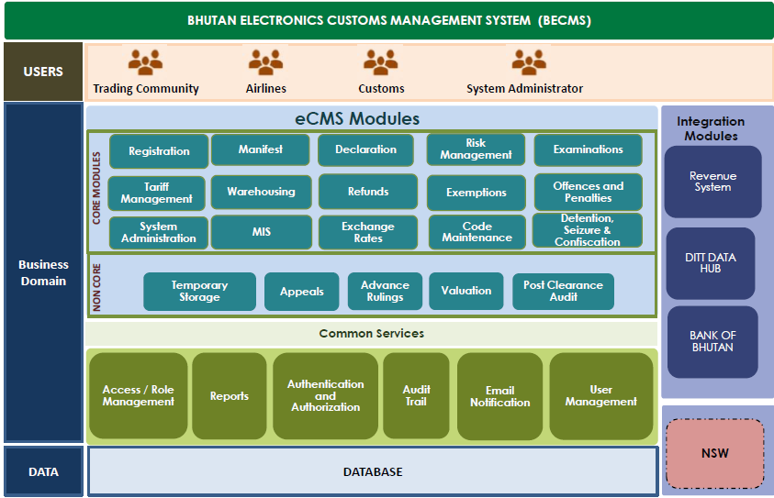

Microservices Architecture

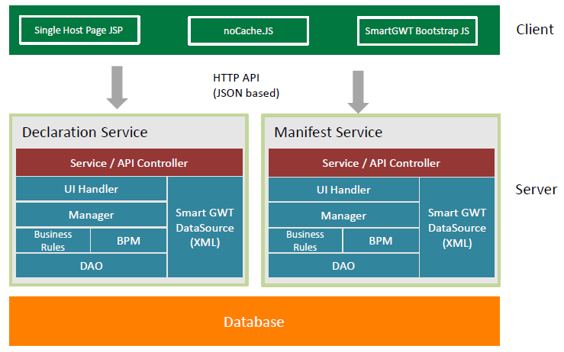

Design viewpoints

Interface viewpoint

The Interface design focuses on the screen designs for various services provided by the Registration module.

The screen to apply for registration as a Clearing and Forwarding Agent (CFA) is provided below.

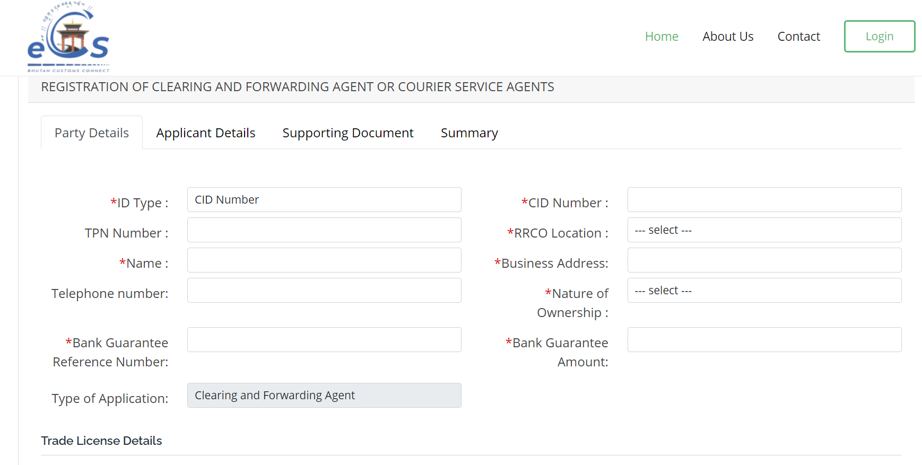

Screenshot for Registration of a CFA

The screen to apply for registration as a Warehouse Operator (WHO) is provided below.

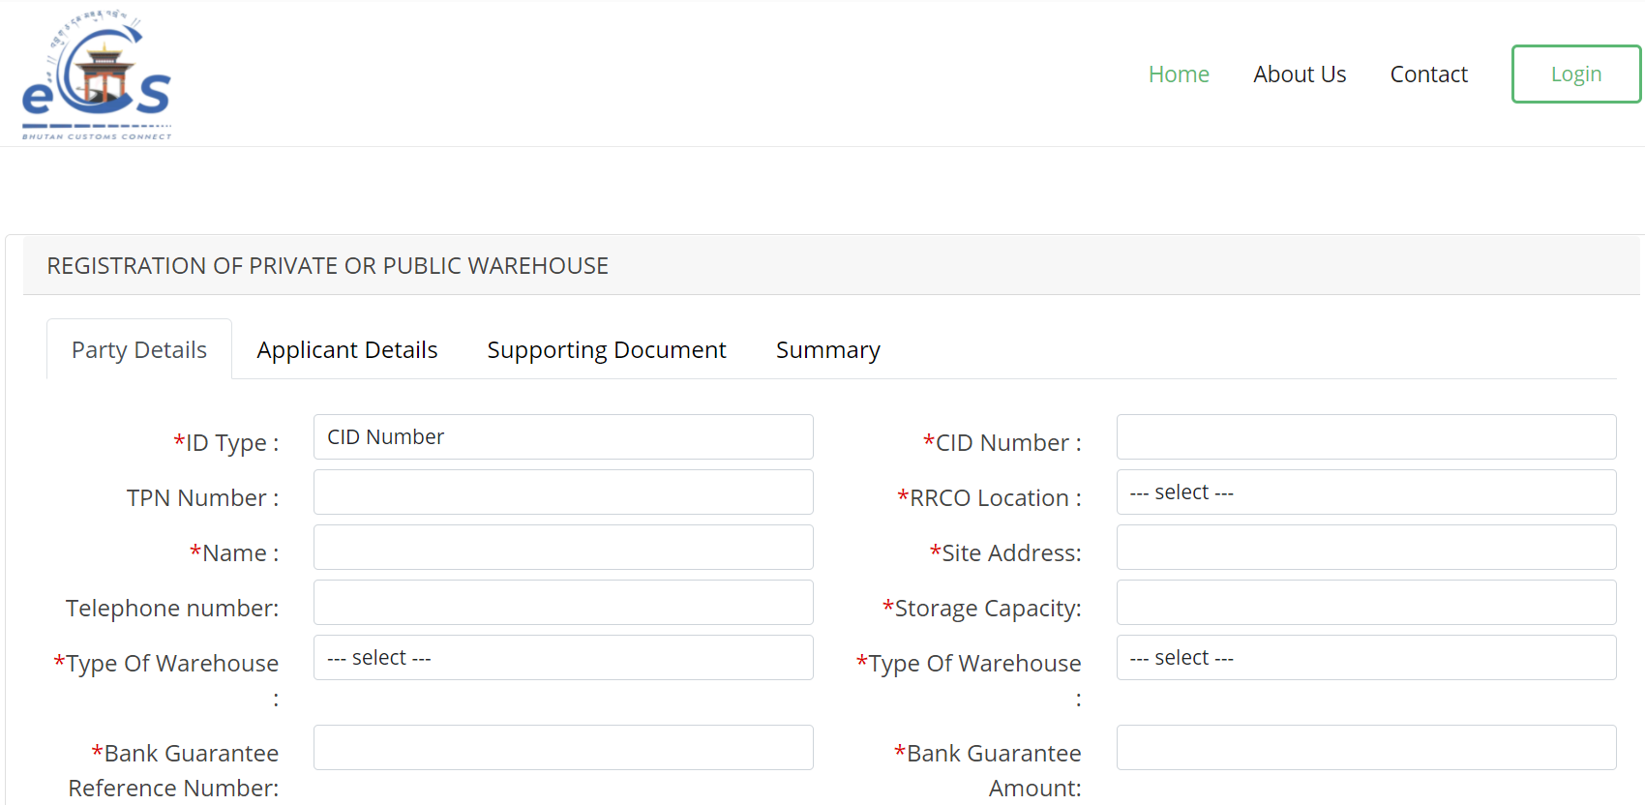

Screenshot for Registration of a WHO

Dependency Viewpoint

The Registration module uses quite a few classes that share information and parameter among themselves to achieve the required functionalities. The package diagram of registration module is provided below.
logging
ORM
data
business
web
RegistrationController
Config
exception
RegistrationService
Config
exception
servicehelpers
RegistrationDAO
Config
exception
daohelpers
mysql-connector.jar
MySQL JDBC Driver
datasource
type
data
values

System Database Schema

ER Diagram
(Example)
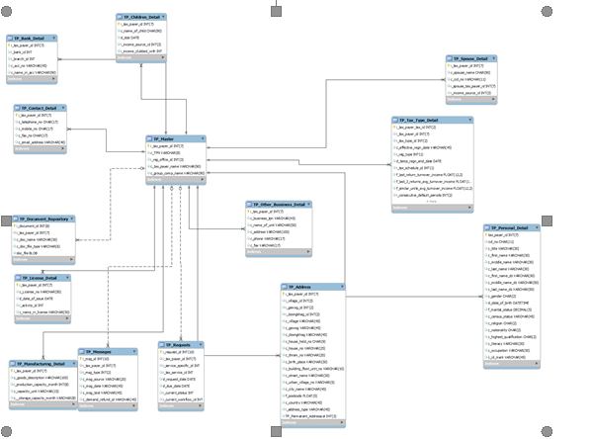

Table Name | Purpose
<Table Name> | <Purpose of the table>

Field Details

